Practical No 3

3 Implementing Aggregation

a Write a MongoDB query to use sum, avg, min and max expression.

Sum:

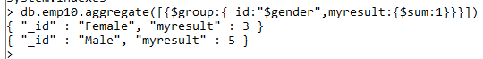

Avg:



Min:



Max:



b Write a MongoDB query to use push and addToSet expression.



c Write a MongoDB query to use first and last expression

First :

Last: